**ESE 3005**

**Lab #7 Write a Program on Eclipse and Compile it on the ARM (BBB) by Using Cross Compilation**

**Group members:-** Shahrukh Padaniya

Rohan Yadav

Swapnil Sevak

Method A:

Write any short or simple C program such as a Hello World and compile the code and display the output of the code on your Beaglebone by Configuring Eclipse for Cross-Compilation (Deadline: April 7)

**Step 1. In eclipse, first create a new C project.**

We need an eclipse for this. After installing eclipse, click on the “file” option on the top left side and select “new” and then “ C / C++ project”.

**Step 2. Once the C project is created, add source file in C project (such as a Hello World) by using extension .C**

Select C managed build and then give project name such as “helloBeagle” as in our example.

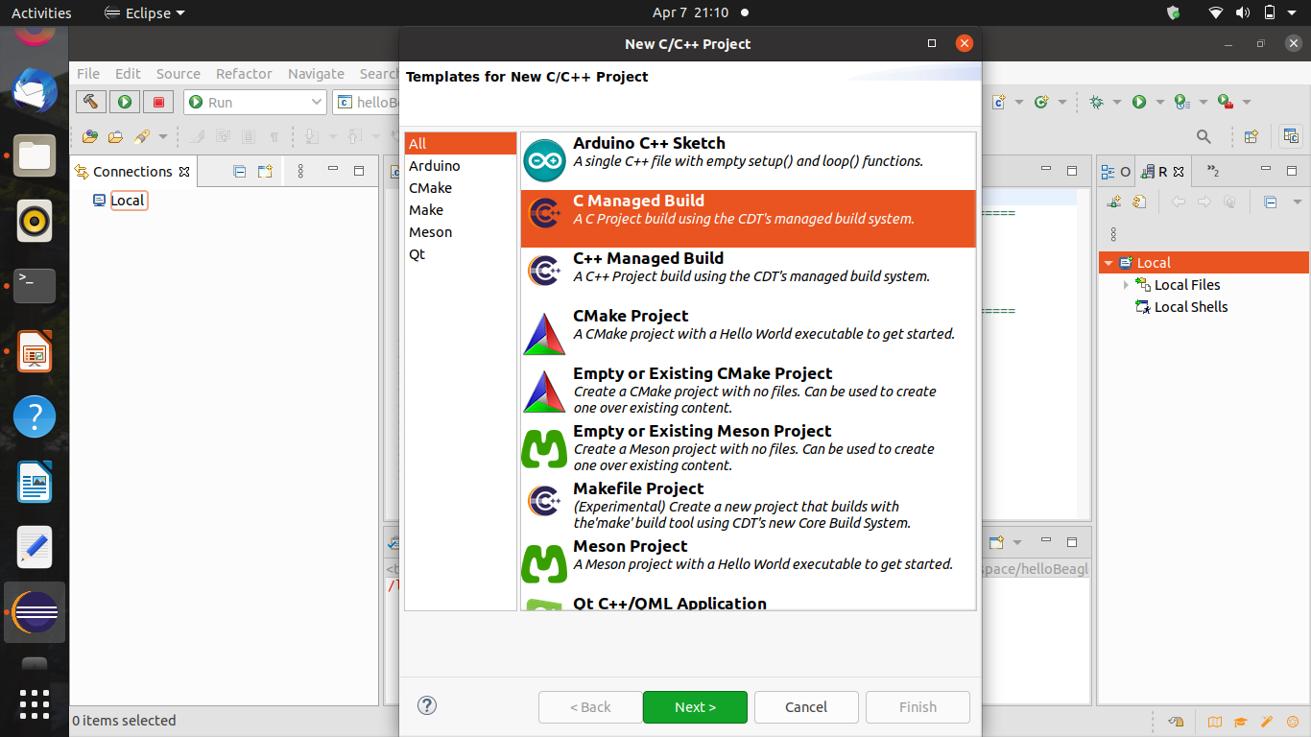

**Step 3. While making the C project it is important to select cross GCC, as we will do cross compilation .**

Select cross GCC build. Also select Debug and Release option in next page.

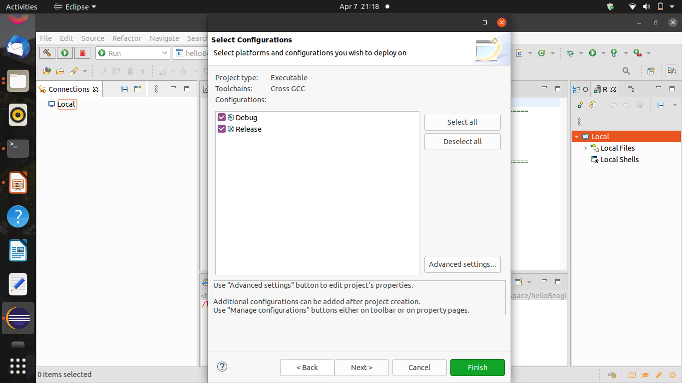

Tip: You can find the instruction in the lecture file (Configuring Eclipse for Cross-Compilation section)

**Step 4. In C project, select properties and add prefix and path of the ARM**

In the next page, select cross compiler prefix as “arm-linux-gnueabihf-” and cross compiler path as “usr/bin”

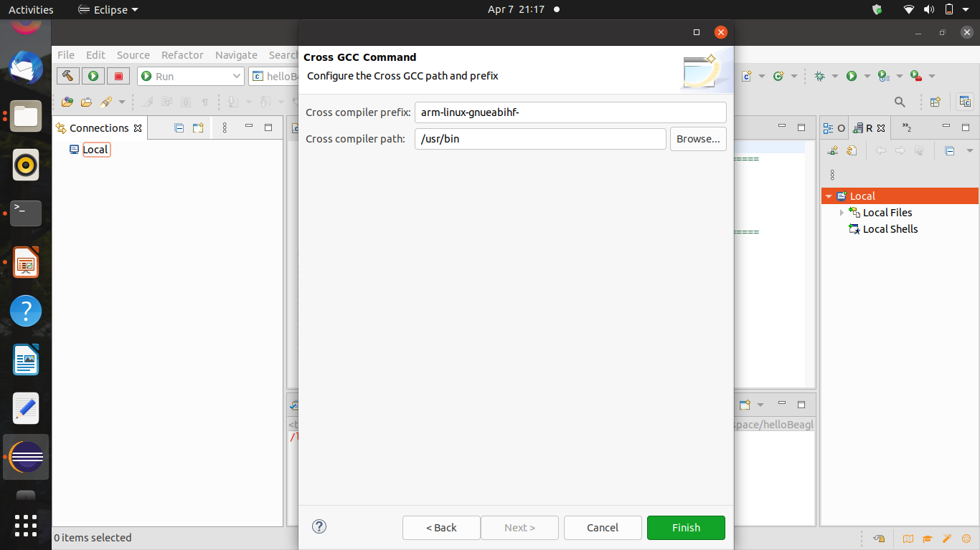

**Step 5. When the setting is done on Eclipse, transfer the project to the Beagle Bone**

**Tip: Sftp debian @ 192.168.7.2**

After this, click on finish and write hello world program. Then click on build all. It will make different files after this in the debug folder. We need to transfer this files to beaglebone, for which we need to use sftp command.

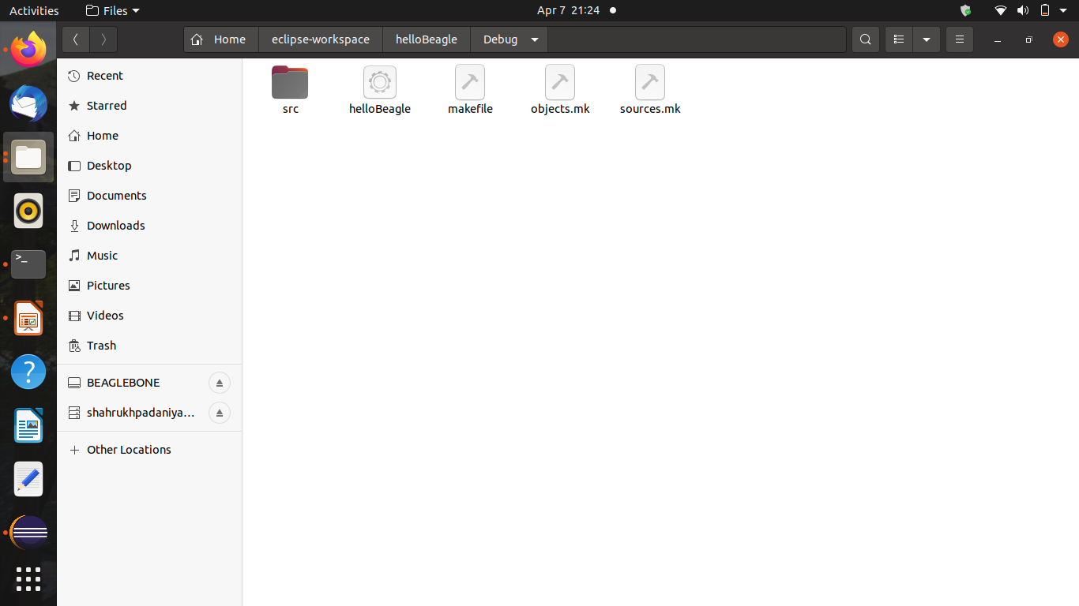

shahrukh@shahrukh-Inspiron-15-3567:~$ sftp debian@192.168.6.2

sftp> put -r eclipse-workspace

sftp> exit

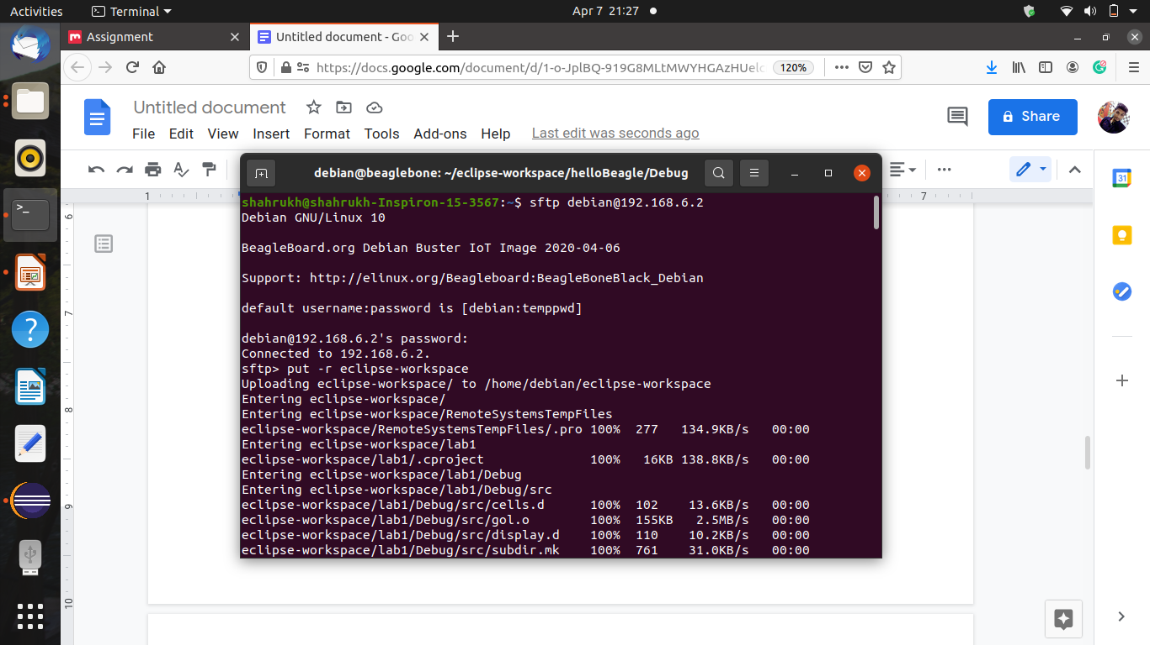

**Step 6. Login the Beagle Bone by using command : sudo ssh 192.168.7.2 –l debian and ensure the executable file is already created in BBB (How?). To check the results, run the code!**

To login to beaglebone, use the command below. Also we can check if the files are present by using the ls command.

$ ssh debian@192.168.6.2

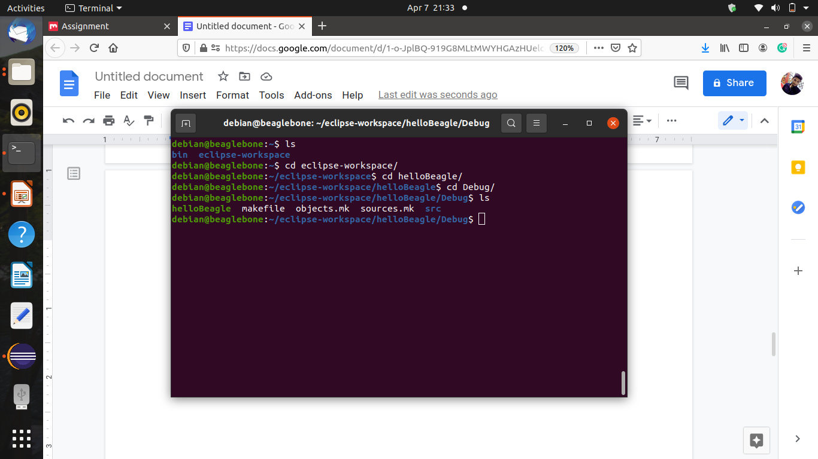

To run the code, we need to insert the filename with prefix ./ as shown below

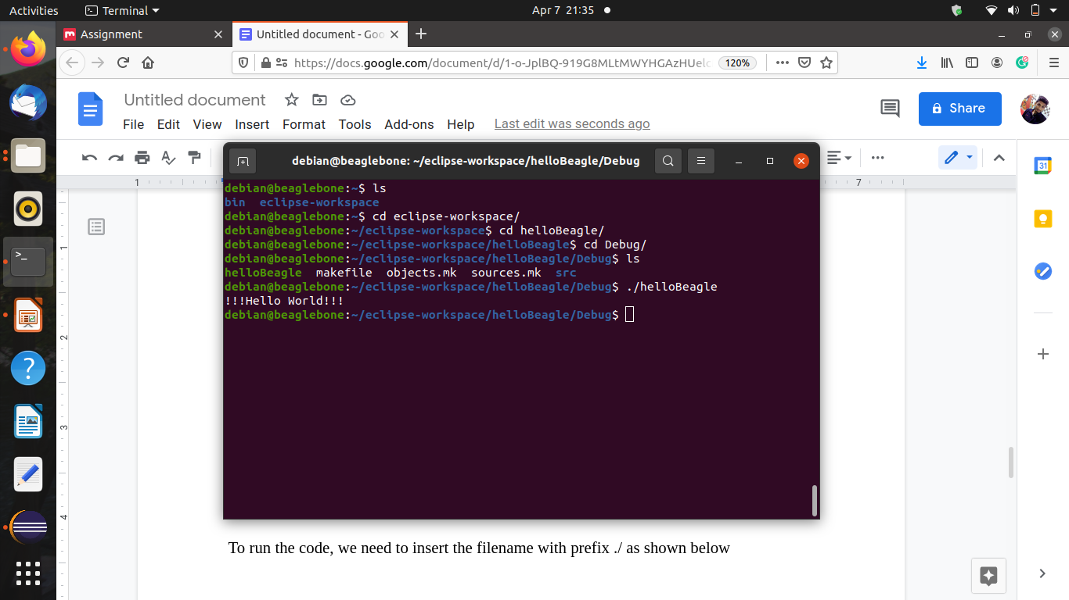

**Method B:**

**Write any short or simple C program such as a Hello World and compile the code and display the output of the code on your Beaglebone by Remote System Explorer (Deadline: April 7)**

**Required steps: This time try to install the remote system explorer within your Eclipse environment and run the same C project on your board through a direct connection between your Eclipse environment and your Beagle board, over a network connection, by using the SSH server on your board.**

**Tip: You can find the instruction in the lecture file (Remote System Explore section)**

We need to add “Remote System Explorer User Actions” as well as “Remote System Explorer End-User Runtime”. For this select help in eclipse and install new software. After this type “2020-06 - http://download.eclipse.org/releases/2020-06” in work-with part and in filter text type “remote”.

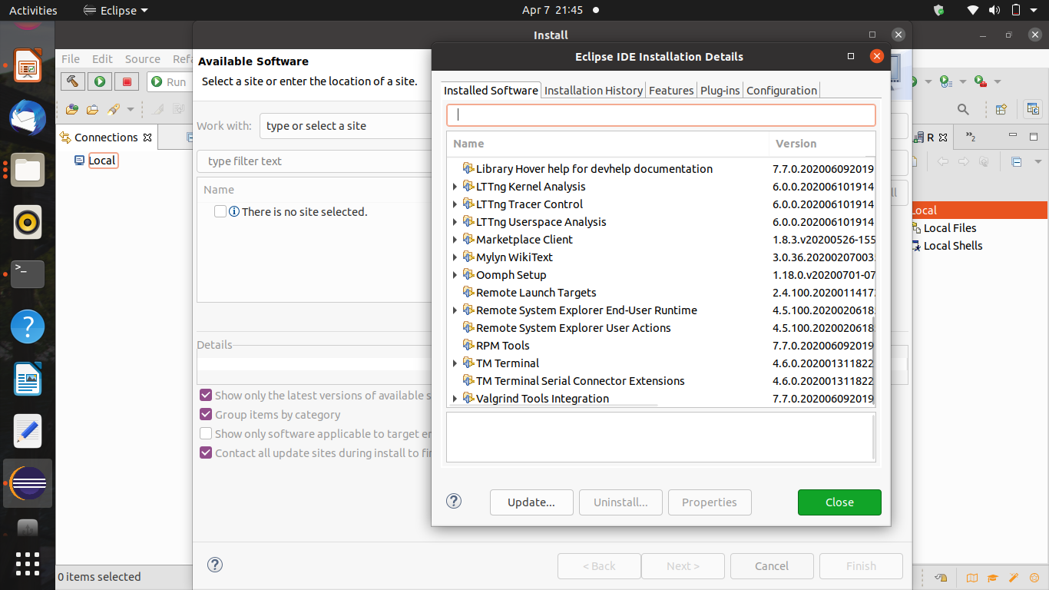

Step 2:- Follow the steps mentioned in the lecture and proceed.

In the Remote Systems frame that appears, click the Define a Connection to Remote System icon, and in the New Connection dialog, select the following:

Choose Linux Type and then click Next.

For Host Name, enter your board’s IP address—e.g., 192.168.6.2

For Connection Name, change it to Beaglebone and then click Next.

For [Files] Configuration, select ssh.files and then click Next.

For [Processes] Configuration, select processes.shell.linux and then click Next.

For [Shells] Configuration, select ssh.shells and then click Finish.

To connect to the beaglebone board remotely: you can right click on Beaglebone entry on the Remote Systems tab and Connect. You should use Debian as the User ID and temppwd as the Password. Proceed with the connection.

After we switch to debian in beaglebone. Go to the file and use commands as in step 1. We get the output on eclipse.

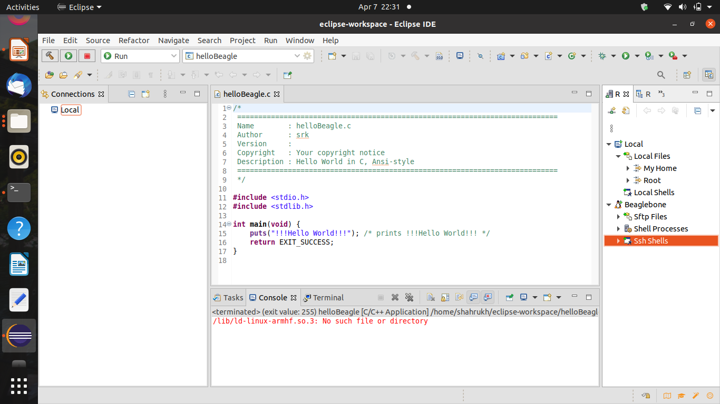

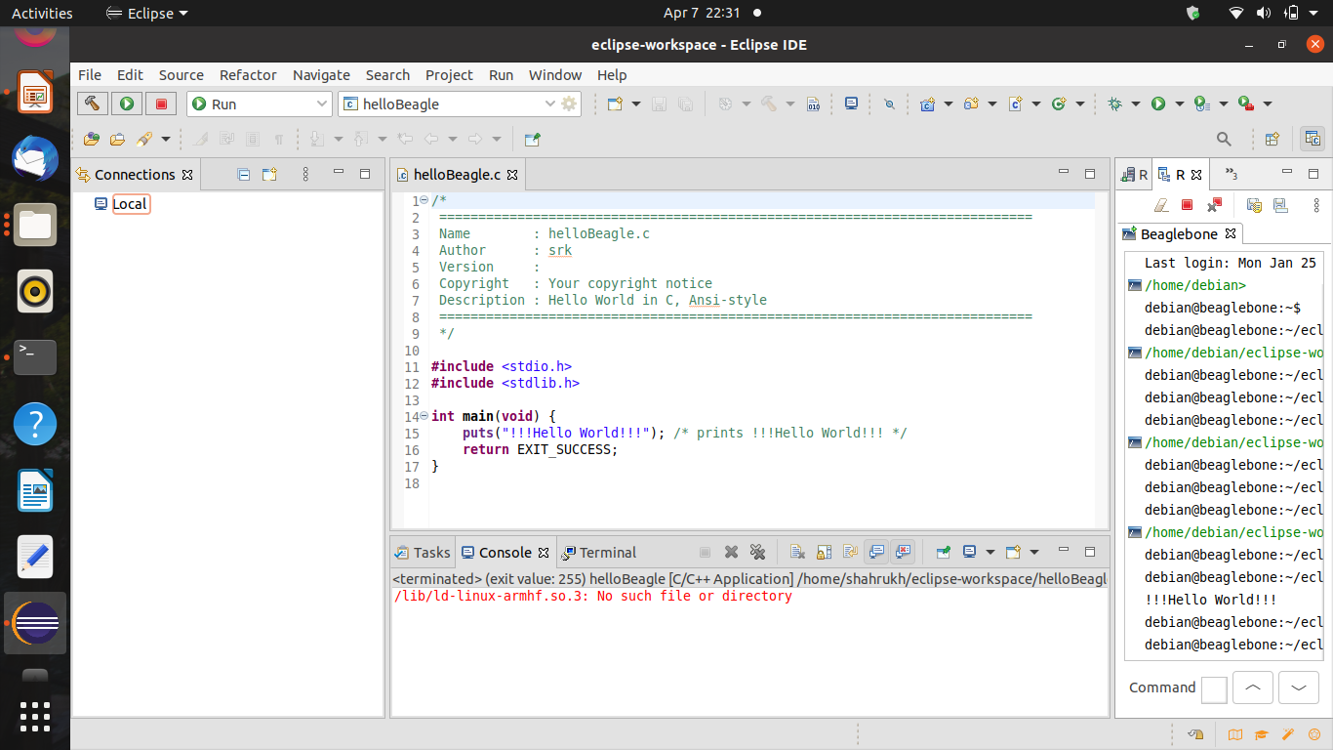

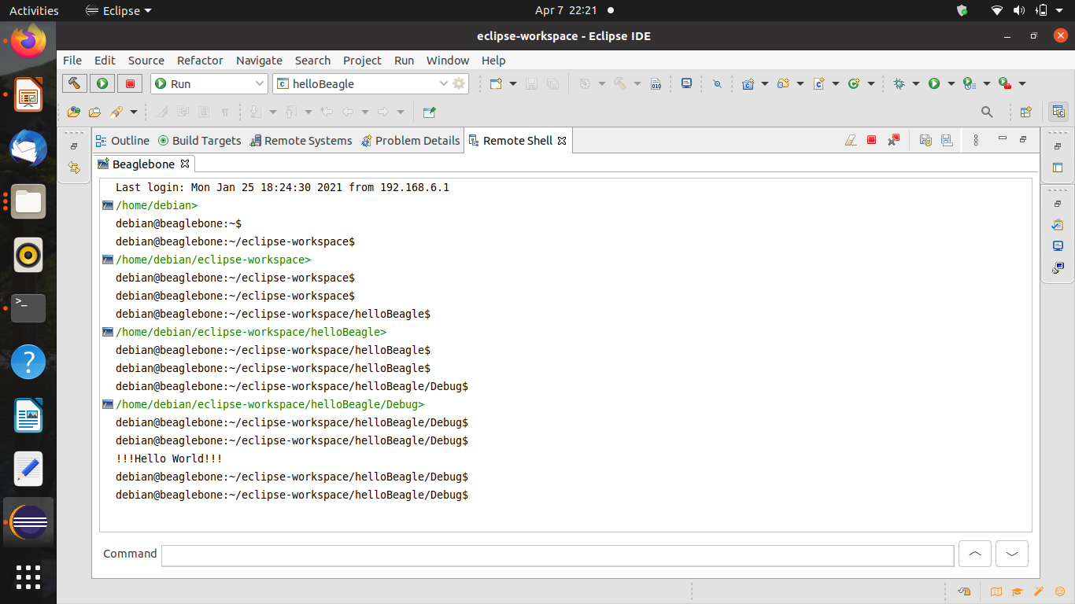

Step 3. While making the C project it is important to select cross GCC, as we will do cross compilation .

Tip: You can find the instruction in the lecture file (Configuring Eclipse for Cross-Compilation section)

Step 4. In C project, select properties and add prefix and path of the ARM